

Latvijas Universitātes Vadības un uzņēmējdarbības mācību centrs

(LU VUMC)

**IEVADS PROGRAMMATŪRAS TESTĒŠANĀ**

2021

ESF projekts Nr. 8.4.1.0/16/l/001  
‘’Nodarbināto personu profesionālās kompetences pilnveide”

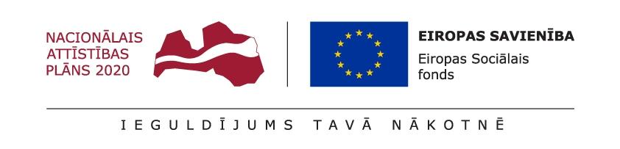

**Intervijas jautājumi**

1. **What is White Box testing?**
2. **What is Black Box testing?**
3. **Explain the difference between Authorization and Authentication in Web testing.**
4. **Define HTTP.**
5. **Define HTTPS.**
6. **What is the difference between functional and non functional tests**
7. **What is accessibility**
8. **What is integration testing**
9. **What is unit testing**
10. **What is regression testing**
11. **What is acceptance testing**
12. **What is the difference between positive and negative scenarios**
13. **Is it possible to do exhaustive testing**
14. **Are defects clustered?**
15. **What is SDLC**
16. **What is SCRUM**
17. **What is AGILE**
18. **What is STLC**
19. **What is equivalence partitioning**
20. **What boundary values would you test**
21. **What is specification**
22. **What are acceptance criteria**
23. **What is a test plan**
24. **What is a test scenario**
25. **What is a test management tool**
26. **What tests would you automate?**
27. **What tests would you not automate?**
28. **What is a mind map**
29. **What is a bug**
30. **What is severity**
31. **What is priority**
32. **What is the difference between severity and priority**
33. **What is Jira**
34. **What are logs**
35. **What are common objectives of testing**
36. **What is exploratory testing**
37. **What is Ad-hoc testing**
38. **What is waterfall**
39. **What is SQL**
40. **When do you need SQL**